GUI Design for CGPA Calculator:

PYTHON SYNOPSIS

Couse Name:-Pyhton Programming

Course Code:-INT213

Submitted by:

1.Rohan Pandey

2.Ayush Sharma

3.Abhishek Rana

Submitted to:Miss Chavi Kapoor

INTRODUCTION:

In this project we are desigining a GUI application for CGPA

Calculator of a student using python programming language.

This calculator will be calculating the TGPA based upon the two semester.First it takes the number and grades to calculate the TGPA for a particular term.

Code output:

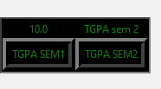

And then in the same way we can calculate the CGPA by the given garades.

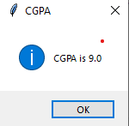

OUTCOMES:

This calculator is useful for those students who don’t know how to calculate the CGPA .

Further we will come to know about the algorithm behind the CGPA and TGPA.

The sleek user interface enhances the usability and makes it easier for the students to use it.

DESCRIPTION:

For calculating TGPA consider subject1 where someone has got grade A+ and the subject has a credit of 4.

O:Outstanding-10

A+:grade point-9

A:grade point-8

B+:grade point-7

B:grade point-6

C+:grade point-5

C:grade point-4

E:grade point-3

F:Fail

For example:

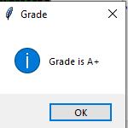

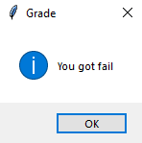

RESULT OF THIS GUI PROJECT:

This calculate will help the students to clarify their CGPA so that there are not in any doubt to calculate their result.

In this project we also use the matplot libraryies to get the comparision between the grades.